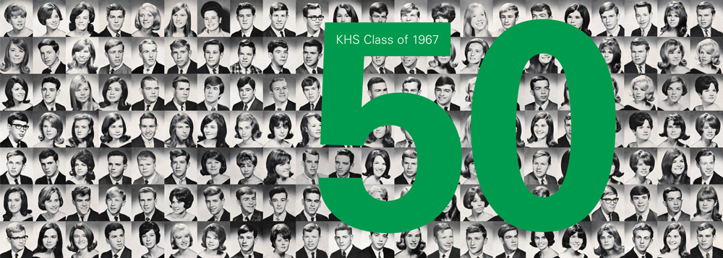
KHS Class of 1967 50th Reunion Celebration
Reunion Information ~ Suggestions
Dining

Cabana El Rey - 105 E. Atlantic Ave Cuban
Caffé Luna Rosa – 34 S. Ocean Blvd Northern Italian
El Camino – 15 NE 2nd Ave Mexican
City Oyster – 213 E. Atlantic Ave Seafood
Tramonti – 119 E. Atlantic Ave Italian
Cut 432 - 432 E. Atlantic Ave Steakhouse
J&J Seafood Bar & Grill – 634 E. Atlantic Ave Seafood
Scuola Vecchia Pizza e Vino – 522 E. Atlantic Ave Pizza
Park Tavern – 32 SE 2nd Ave American
Rocco’s Tacos and Tequila Bar – 110 E. Atlantic Ave Mexican
Rack’s Fish House and Oyster Bar – 5 SE 2nd Ave Seafood & American

Recreation General Information

Golf www.delraybeach.com
Tennis
Boating www.tripadvisor.com
Beaches
Sightseeing
Galleries
Museums
Transportation

- Finest Transportation, Inc. - 561-477-6222 to Schedule - Open 24/7 (Tom or Michael)
- PBI Airport to Hotel $45
- Fort Lauderdale to Hotel $55
- Delray Downtowner 561-702-8519 www.ridedowntowner.com (free shuttle within 2 miles of hotel)
- Downtown Roundabout 561-243-7322 (free shuttle) www.mydelraybeach.com
- Katch-A-Ride 561-404-3393 Golf cart rides around town (for tips only)

Attractions

- Delray Beach: Ocean Side Beach Services - 561-840-3373
www.beachservice.com
- Across the street from Delray Beach you can walk to Boston’s On the Beach, Caffé Luna Rosa and the Tiki Hut for Food and Refreshments
- Delray Artist’s Alley - 300 Block of 3rd Street
- Morikami Museum and Japanese Gardens - 561-495-0233
www.morikami.org
- Pineapple Grove Arts District - NE 2nd Street
- Art Galleries along Atlantic Ave
- Wakodahachee Wetlands - Jog Road, Delray Beach (Fabulous Photo Ops)
- Loxahachee National Wildlife Refuge – Lee Road, Boynton Beach
- Delray Yacht Cruises - Veteran’s Park, E. Atlantic Ave 561-243-0686
www.delraycruises.com
- Everglades Holiday Park – Airboat Tours – Ft. Lauderdale – Airboat Tours
- Restaurants and Shopping Galore – Atlantic Ave

