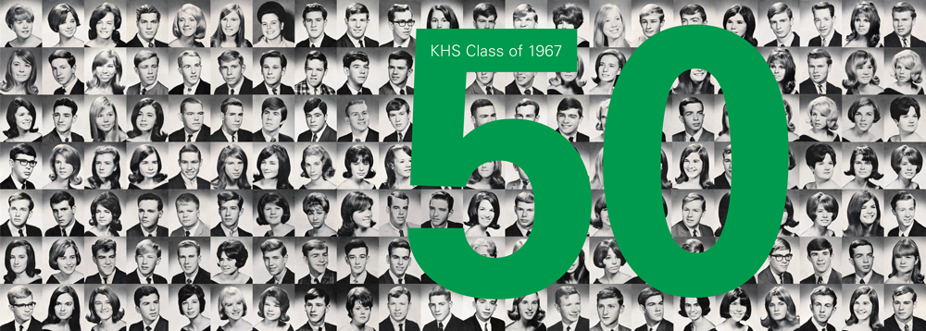
KHS Class of 1967 50th Reunion Celebration
kinnelonhighschoolclassof1967.com
Delray Beach, Florida
(Voted one of America’s Happiest Seaside Towns)

Thursday, October 19 – Sunday October 22, 2017
Hyatt Place Delray Beach
(561) 330-3530
http://delraybeach.place.hyatt.com/en/hotel/home.html
$159 King
$169 Double
Rooms must be booked by August 15th for KHS rate

Thursday, October 19, 2017
- 5:00-7:00pm Happy Hour and Appetizers at Hyatt Lobby Bar ~ Cash Bar
- Explore Delray’s Many Fine Restaurants

Friday, October 20, 2017
- 6:30-9:30am Hyatt Place Breakfast (complimentary)
- 9:45am Pickup for Transit to Wakodahatchee Wetlands (a nature reserve that is the #1 Tourist Attraction in Delray Beach) 12:00pm Pickup for Return Transit to the Hyatt ~Sponsored by Pat and Suki
- 12:00-5:00pm Optional Fun Time (many activities listed on KHS Website)
http://www.downtowndelraybeach.com/things-to-do
http://www.delraybeach.com

- 5:00-7:00pm Happy Hour and Appetizers at Hyatt Lobby Bar ~Sponsored by Woody, Doug, Phil and Russ
- 7:00-10:00pm Free Concert and Food Trucks in the Amphitheater of the Old School Square around the corner from Hyatt
- Optional Dining on the Avenue (see website for suggestions)
- 10-12:00pm After-Party at Hyatt Lobby Bar

Saturday October 21, 2017
- 7:00-10:00am Hyatt Place Breakfast (complimentary)
- 10:00-5:00pm Free Time (Beach, Golfing, Tennis, Water Sports,
Shopping, Galleries ~ check KHS Website)
- 5:00-7:00pm Happy Hour and Appetizers on the Intracoastal at Che Restaurant, 900 E. Atlantic Ave ~ Cash Bar
  - (Note: Class Photo will be taken at this location)
- 7:00-9:00pm Dinner at Che Restaurant
- Live music nearby

Sunday, October 22, 2017
- 7:00-10:00am Hyatt Place Breakfast (complimentary)
- Free Time

$125.00pp payable by August 15, 2017

Make Check Payable to: KHS Class of 1967

Send Checks to:
Russ Sacco
209 Rock Ridge Road
Boonton Twp, NJ 07005

Make it your reunion. Make it a vacation. Come early ~ stay late for the same room rate. Either way you’ll have a fabulous time!
**Your Help, Thoughts and/or Sponsorship are welcome. Please let us know.

